Act Fast

A basketball player jumps up and gets a rebound. A driver swerves to avoid hitting a squirrel in the road. These two situations are good examples of when a person must react quickly. The amount of time it takes your body to respond to something is called reaction time. Measuring reaction time is easy to do and yields interesting data to analyze about yourself and others.

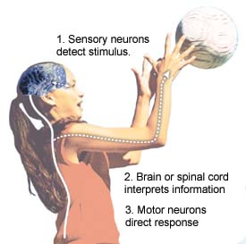
Through your five senses—sight, hearing, touch, smell, and taste—your body recognizes when something is happening to it. For example, you see a ball coming toward your face. Your body responds by putting up your arm to block the ball. This happens because a message is sent within your body from your eyes to your brain. Your brain decides you don’t want to get hit by the ball and sends a message back to the muscles in your arm to block the ball.

In the example, the ball coming toward your face is a stimulus—a change inside or outside the body that is detected by the senses and leads to some kind of action. The time it takes for this message to travel from your eyes to your brain and then to your arm muscles is called reaction time. A response is something the body does as a reaction to the stimulus. Blocking the ball is the response.

The Nervous System
Reaction time involves the nervous system recognizing a stimulus and then directing the muscles to take some kind of action. Special cells in the nervous system called neurons carry messages to and from the brain and spinal cord. Sensory neurons detect a stimulus. Additional neurons carry the message about the stimulus to the brain or spinal cord, which interprets the information and decides on some type of action. A message is then carried back to motor neurons. Motor neurons direct the muscles to carry out the response. All of this activity within your nervous system happens in a fraction of a second. That fraction of a second is measured as reaction time.

Use the directions below to measure your own reaction time and compare it to that of a family member or friend. *Record your findings in a data table and answer

Materials:
- 1 ruler with inch and centimeter markings
- 1 friend or family member as a partner

Time needed:
5 minutes

Directions:
1. One partner holds the ruler vertically with the 0 cm end facing down while the other partner holds his or her thumb and pointer finger at the bottom of the ruler—ready to catch the ruler when it is dropped.
2. The person holding the ruler lets it drop without warning and the other person tries to catch it as quickly as possible.
3. Record the centimeter mark on the ruler where the ruler was caught (use the mark closest to the bottom of the thumb). Record the number on the chart below.
4. Repeat five times and calculate the average (mean). Switch places and test your partner.
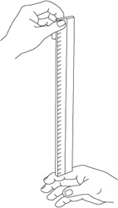
Act Fact Name_________________Per______

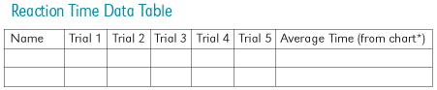

*The chart below converts the measurement of where you caught the ruler to a specific time. For example, if you caught the ruler at an average of 18 cm, your reaction time would be 0.19 seconds. You will need to select the centimeter reading on the chart closest to your average (after rounding).

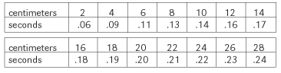
Questions:

- Did your response time change over time (over the five trials)?

- What circumstances might affect your reaction time?

- Can you think of situations where reaction time is important?

- Test the reaction time with your nondominant hand
(the hand you don’t write with). Can you explain any differences you found? Materials:

**Visit the websites below to try some online reaction time experiments:
www.exploratorium.edu/baseball/reactiontime.html
www.explorescience.com/activities/Activity_page.cfm?ActivityID=38

