1st- Using CHROME if possible, go to https://www.legendsoflearning.com/
CLICK on STUDENT/TEACHER Login in the
TOP right-hand corner.

2nd- Select STUDENTS
3rd- ENTER TEACHER CODE VANZAN2
If your teacher gave you a different code,
use that.
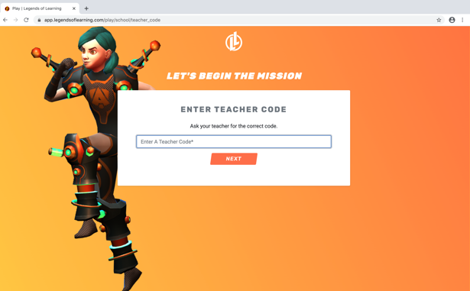
4th- Select SIGN-UP if you don’t have an account with your teacher already.
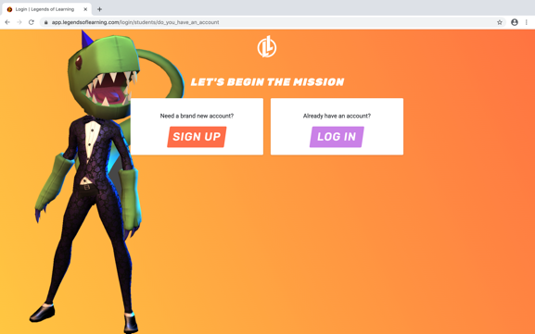
If you already have an account, log in.
5th - Create NEW ACCOUNT
USERNAME should include your first name and last initial or your initials.

6th-Create PASSWORD. Use your PowerSchool ID numbers (like your computer login).
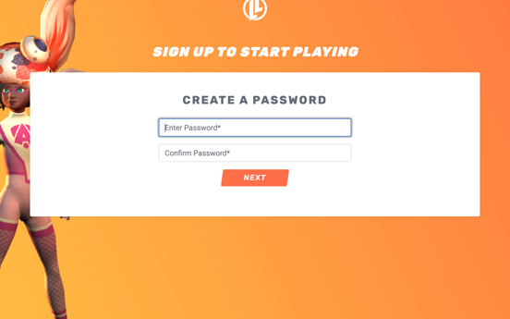

7th-Enter FIRST NAME and LAST INITIAL
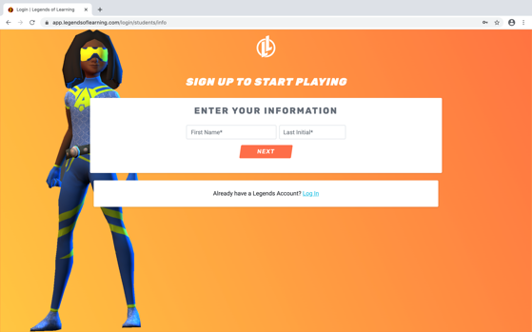

8th-Take a SCREENSHOT of log-in info or write it down or add to password folder.
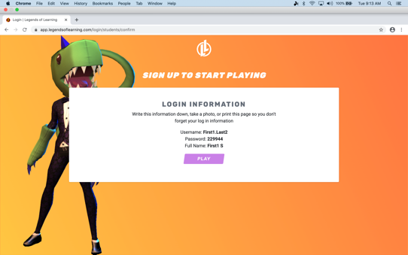
9th- Begin YOUR PLAYLISTS assigned for MATH PRACTICE.
10th For ENRICHMENT, play The Awakening!

