Name_______________________________________
Revolution in Russia Reading Questions
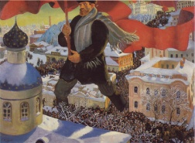
Directions: Read Ch 26, Sec3 and answer the following questions.
- Who were the Bolsheviks? What was their goal?

- What is a proletariat?

- What did the czar hope WWI would do for Russia?

- What disadvantages did Russia have in WWI?

- How was the czar taking control of the army a bad idea – both at home & abroad?

- What were people protesting in Petrograd in 1917?

- What type of government did Russia adopt once Czar Nicholas stepped down as czar?

- What did the Marxists hope to accomplish with their revolution against the temporary government? When did they manage to stage a revolution?

- Why did the Germans send Lenin back to Russia?

- What agreement did Lenin’s advisor Leon Trotsky make with the Central Powers?

- Who was the civil war in Russia between?

- In 1921, what did Lenin’s New Economic Policy allow for Russia?

- What was the Union of Soviet Socialist Republics?

