Name: ____________________________________ Date: ____________________ Class: __________
Week Four Activity #3

Disney has lost a lot of customers lately because they have not built a new roller coaster or attraction in many years. They are conducting a nationwide search for the best roller coaster or ride design. They are looking for a roller coaster that is new, exciting, and thrilling to those who ride it. Your job is to come up with a new roller coaster design or ride for Disney to use in their park. Without a new roller coaster/ride, Disney will surely close. Disney is very strict about the requirements of the design, so you must pay attention to details at all times. They are concerned about the attractiveness of the ride, but also the science. Students will create a ride for a theme park describing the forces that would act on it. Be sure to answer each of the questions associated.
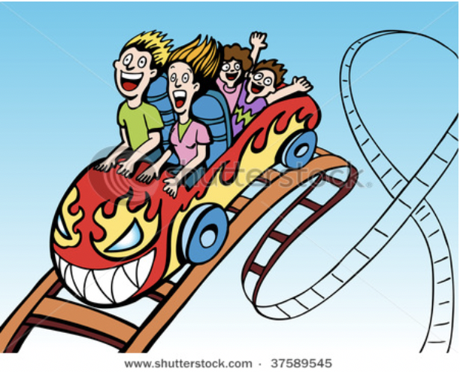

Be Creative!

-Before beginning watch the video-(The Science of Disney Imagineering: Electricity)
-Design a ride or attraction for a Disney Style theme park that does not use electricity.
- Describe the forces that you will use instead of electricity (gravity, force, other sources. Remember that people
have lived on Earth for thousands of years without electricity.)
-Draw or use your artistic skills (hand or computer) to show what the ride/attraction would look like.
-Make an advertisement (poster on paper or quick trailer) about your new ride/attraction.
-Describe the forces being used and how they work together.
-Explain why you chose each force.
-A labeled point showing where gravity is affecting your roller coaster the most through the ride.
-What materials will be used?
- What will the highest point or maximum height of the tallest part of the ride?
- What is the mass of the ride itself?
-How many people will be needed for it to work properly and what will be the role of each person?
-How will it operate from start to finish?
-What is the name of your new ride/attraction?
-Calculate the gravitational potential energy (GPE) of your roller coaster.
GPE = mass x gravitational acceleration x height

