0-3 months | 6-12 months | 1-2 years
Toy Guessed:  Why is this a good toy for this age group? | Toy Guessed:  Why is this a good toy for this age group? | Toy Guessed:  Why is this a good toy for this age group?
3-4 years | 5-7 years | 8-10+ years
Toy Guessed:  Why is this a good toy for this age group? | Toy Guessed:  Why is this a good toy for this age group? | Toy Guessed:  Why is this a good toy for this age group?
Directions: As your rotate through the stations, guess which age group you believe this toy is best suited for. Then, defend your choice by answering the “why” question in each category.

Toy Choices:
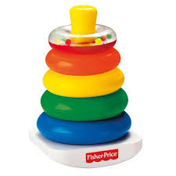  Stacking Rings | 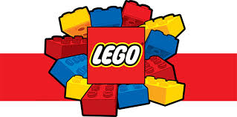  Lego Blocks | 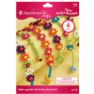  Craft Sets | 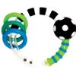  Rattle/ Textured Rings | Play-Doh | 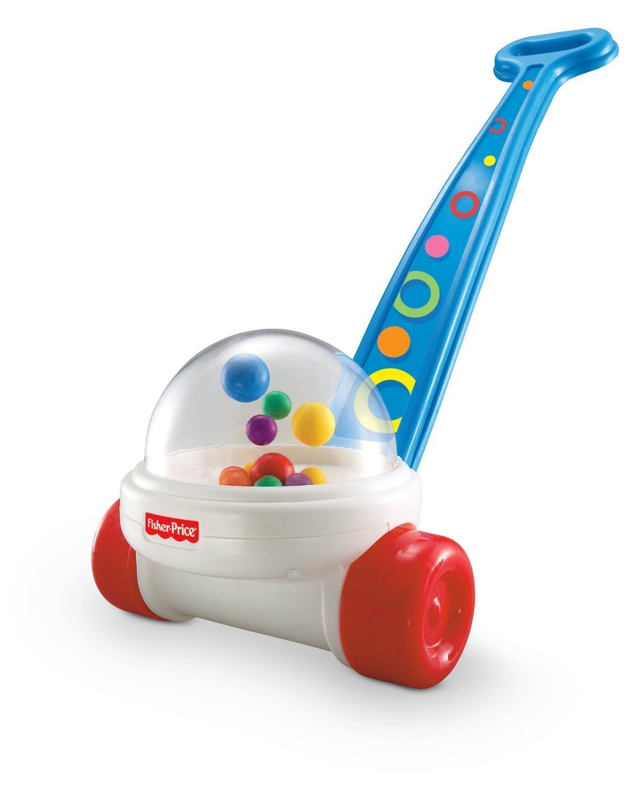  Popping Walker

