How Does a Pandemic Cause Less CO2?

Introduction

In this task, How does a pandemic cause less CO2? you and your family engage in science and engineering practices to make sense of the phenomenon of concentrations of greenhouse gasses decreasing as the world-wide spread of the coronavirus increases.
You will then apply the science ideas you build to design a system or process to decrease your contribution of carbon dioxide to the atmosphere- in other words, reduce your family's carbon footprint. While you can complete this task independently, we encourage you to work virtually with peers or in the home with family members.

This task was inspired by the story, Satellite images show less pollution over the US as coronavirus shuts down public places, published by CNN on March 23, 2020.

Click the link below; watch the video, read the article; refer to the charts.

https://www.cnn.com/2020/03/23/health/us-pollution-satellite-coronavirus-scn-trnd/index.html

Part 1: Pollution Decreases in China

Open the document below. Review the charts. Notice that the charts are comparing nitrogen dioxide levels but your lesson is over carbon dioxide levels.

https://docs.google.com/document/d/1Xo8XTu1_bozgFt7QQTYhl98gki_AHSx6KP40Lo-4yiU/edit?usp=sharing

NO2 is a harmful gas emitted by motor vehicles, power plants and industrial facilities into the atmosphere. These same sources also emit carbon dioxide (CO2).

View the nitrogen dioxide (NO2) concentration data for greater China and Wuhan, Hubei province, China.

- What patterns do you observe in the data presented in each set of maps? (Discuss with friend or family member.) Write the observations you made.

- What questions does this raise for you?

- Why did the numbers go down?
- Why is it in the news?
- Why did the numbers go down more in Wuhan than other cities in China?
- Does this have something to do with the coronavirus?
- Is pollution going down in other places? In the United States?
- Is this because people aren't driving cars?
- Why is NO2 measured?
- Is NO2 going down good for people/the environment?
- What does NO2 do to you/the environment?

Part 2: How does CO2 affect Earth's average temperature?

One reason scientists are excited about the current decrease in NO2 concentrations over China is because it indicates CO2 has also decreased. We're going to shift our focus to CO2 because it is a greenhouse gas while NO2 contributes to the formation of a greenhouse gas (ozone) though a series of reactions at an unknown rate."

Please watch the following videos.
*Recall when we studied Matter and Energy Transfer in the Environment.
https://www.youtube.com/watch?v=K9kga9c0u2I&feature=youtu.be

https://www.britannica.com/video/185587/characteristics-Earth-atmospheric-gas-molecules-properties-greenhouse

https://www.pbs.org/wgbh/nova/video/carbon-dioxide-warms-earth/

Create a model to explain how changing the amount of CO2 in the atmosphere causes Earth's average temperature to change. (If you need a template for help, refer to the PDF attached on the lesson page.)

Based on your model and referring back to the charts in part 1,
- What do you predict caused the CO2 (and NO2) to decrease between winter 2019 and winter 2020? (Discuss with a friend or family member; write down your observations.)

Part 3: How can we measure our carbon footprint?

"A carbon footprint is the amount of greenhouse gases - primarily carbon dioxide - released in the atmosphere by the sum of a person's, family's, community's, or nation's activities."

This next part requires assistance by an adult family member. We are only interested in your conclusion.

https://coolclimate.berkeley.edu/calculator

You will complete the Calculate Your Carbon Footprint survey to determine your family's carbon footprint BEFORE the COVID-19 pandemic and AFTER schools and businesses closed. (You will complete the survey twice.) The survey results will give you the total number of pounds of CO2/year emitted to the atmosphere as a result of your family's typical activities (home, travel, eating, and shopping).
Once you have calculated your family’s carbon footprint pre- and post-pandemic,
- What is the percent change in your carbon footprint from pre-COVID-19 pandemic to post-pandemic?"
(The percent change will likely be small.)

Part 4: Engineer a solution to reduce your family's carbon footprint!

"When we go back to our normal daily activities, what might you do to continue to reduce your carbon footprint?"
The Engineering Design Process (EDP) comes in many forms. Engineers enter the EDP to create a new technology - or improve an existing one - to meet a need or want. Engineers on the job may start at any step, depending on the needs of a particular project.
Watch A Strict Carbon Diet, to find out how engineer Saul Griffith is helping his family reduce their carbon footprint. "As you watch the video,
- Can you identify the steps of the EDP Griffith uses to design a solution to the problem of lowering his family's carbon footprint? What's your evidence?" 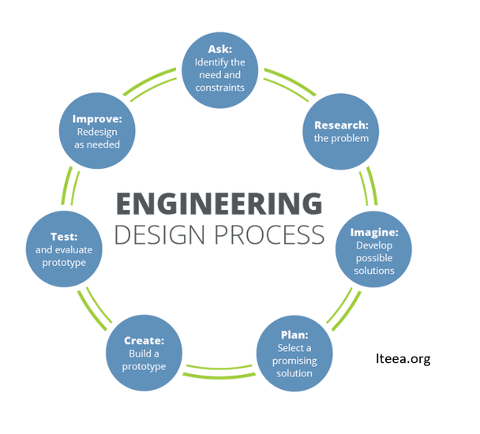

"You can really make a difference by getting your friends, teachers, school and district thinking about reducing their carbon footprints! One way is to explore even more changes to make by checking out the Energy Star website.

*You can also track and change your carbon footprint in real-time by trying one of these mobile Apps: Mobile Carbon Footprinting or Carbon Footprint ACP.

Explore STEM Careers: Environmental Engineer
Meet Marielle Thillet and explore her STEM Career as an Environmental Engineer!"
https://www.youtube.com/watch?v=z6cJ9IULgMk#action=share

What are some of the responsibilities/tasks required of an environmental engineer?

Acknowledgements
The information used in this task are part of the story, Satellite images show less pollution over the US as coronavirus shuts down public places, published by CNN on March 23, 2020.

Additional images from "Airborne Nitrogen Dioxide Plummets Over China" published by NASA Earth Observatory and "Analysis: Coronavirus temporarily reduced China’s CO2 emissions by a quarter" published by Carbon Brief on February 19, 2020.

Modified for distance learning by Kathy Collier, Appling Middle School, May 12, 2020 from NSTA Daily Do’s
https://new.nsta.org/lesson-plan/how-does-pandemic-cause-less-co2

