This activity is due by Friday, April 3rd. You will need to email your filled in worksheet to me at mrshenrymath@gmail.com.

NAME _________________________________________ PERIOD _________ 4/03/20

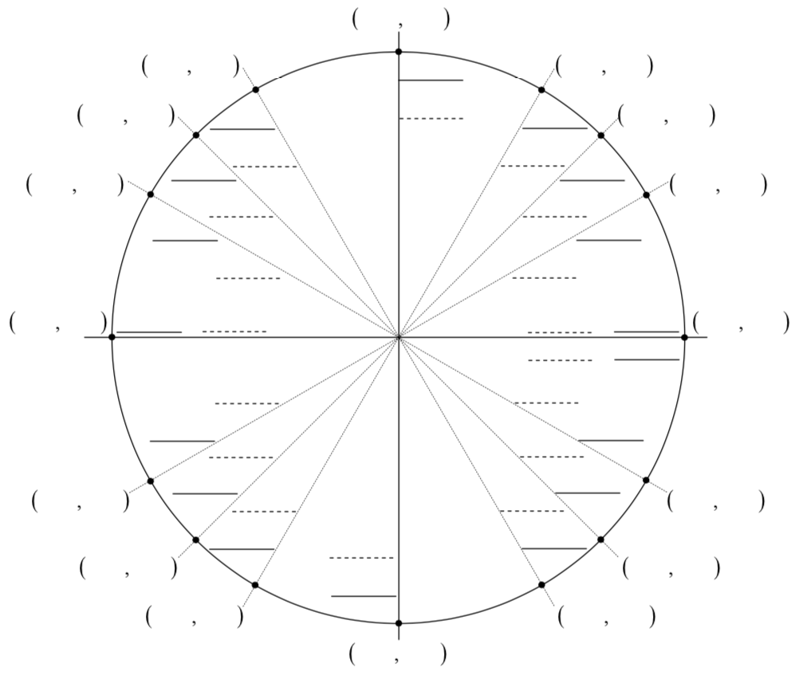
- Fill in the unit circle.
- Answer the questions below about your unit circle.
- Sin ∏/3
- Cos 3∏/4
- Tan 11∏/6
- Csc ∏
- Cot 5∏/4
- Sec 4∏/3

You are allowed to redraw this if needed and answer the questions on your sheet, or you can just fill mine in.

