U.S. Population Growth
The size of a country’s population and its population growth affect the quality of its citizens’ lives. Quality of life is the standard of happiness, health, comfort, and satisfaction experienced by a person or group. Quality of life is diminished when human resources, natural resources, and technology become scarce. Another way to look at this is through the standard of living, which includes the essentials such as employment, health services, housing, food, education, and social services.
In a 2017 survey of Nobel prize–winning scientists, one-third listed human overpopulation and deterioration of the environment (through destruction and depletion of resources) as two of the greatest threats facing humankind.

What Is Overpopulation?
Overpopulation occurs when the human population in a country or specific region grows to the point that it uses up the available resources, causing damage to the environment. Overpopulation can be caused by increases in births, decline in deaths, increases in immigration, or depletion of the resources necessary to sustain life.

U.S. Population Growth
The U.S. population grows about 1 percent annually, which is approximately 3.25 million people a year. Immigration is causing most of the nation’s population growth. New immigrants and their U.S.-born children account for 75 to 80 percent of the annual increase in population. The rest of the growth is the result of births and increases in life expectancy.

Immigration-Stimulated Population Growth
New immigration laws in 1965 increased immigration, and that continues today. It is predicted that the incoming foreign-born Americans and their descendants will be central to the change in the U.S. population over the next 50 years. Over the next five decades, the current U.S. immigrant population of 45 million is projected to grow to 78 million.
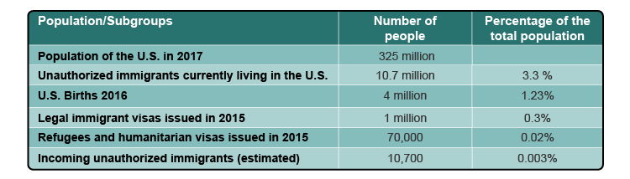

Birth Rate
The birth rate is determined through the calculation of the number of births. The U.S. fertility rate has been increasing since the 1970s, and is currently 2.1 percent. The most significant reason for this increase has been the growth of the immigrant population. Immigrants are most likely to be working age and in their childbearing years. They also tend to have more children than people of the same age range who were born in the United States.

Achieving Population Stability
Population growth can be regulated by legislation and appropriate immigration policies. As the table suggests, the greatest impact comes from legal immigration. The U.S. could adopt a zero-net immigration policy. That doesn’t mean there would be no new immigrants. It means the number of incoming immigrants must be the same as the number leaving. However, no one really knows how many leave the country permanently. Other policy reforms could be directed at expanding temporary worker visas, enforcement of current laws preventing illegal immigration, and family planning education to reduce births.

Preserving the American Dream
The American dream is rooted in old ideas about our country’s seeming unlimited abundance. However, resources are always limited. Some commentators believe that unsustainable levels of population growth are already negatively affecting U.S. resources.
UN-Habitat, a resettlement program, reports suggest that urbanization may be the best compromise in the face of global population growth. Cities concentrate human activity within limited areas, curbing environmental impacts and damages.

Answer the following questions:

- According to the article, what characteristics determine “quality of life”?
- The US population grows about how many people per year?
- The U.S. fertility rate has been increasing since the 1970s, and is currently 2.1 percent. What is the most significant reason for this increase?

