Name:________________________________________________Date:___________Core:_______
Bird Beak Adaptations Lab

Introduction
An adaptation is a characteristic that helps a plant or animal survive in its environment. Birds have been adapting to fit into and survive in their environment for millions of years. Fending off predators, making nests, varying weather patterns, courting mates, feeding young as well as themselves are all things that impact a birds survival. A bird’s beak is a very crucial trait for this survival. For millions of years it has evolved to perfectly fit each birds needs for survival. The size and shape of a beak is specific for the type of food the bird eats. Some birds need strong bills in order to crush seeds while others use thinner versions to sip nectar from delicate flowers.
We will use model beaks and attempt to recreate how a bird eats in a small scale demonstration of adaptations. Think about how a birds beak relates to its prey…….

Prediction and Hypothesis

Match the bird/beak model to the prey model. Draw a line to connect the food to the bird you think...
Heron…..  (scissor) | Spoonbill Bird…  Spoon | Cardinal  Clothes Clip | Duck  Craft Sticks
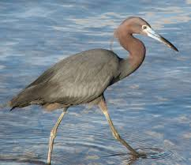 | 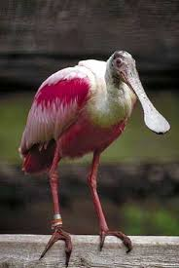 | 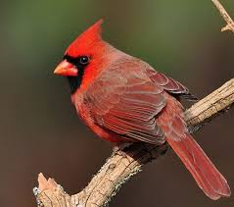 | 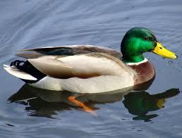
toothpick= small insects | rubber band (or string) = worms | straws = small fish/snail | beads = seeds

Lab Materials

- Pan/bowl | - Cup or Beaker | - Scissors | - Spoon
- Craft stick | - Clothes Clip | - Rubber bands | - Beads
- Straw | - Toothpick
Procedure
- Gather all of your materials.
- Choose a beak to start (scissors, spoon, clothes pin, or craft stick).
- Put one of the prey items into the bowl/pan
- One student will pick up the prey while the other times for 30 seconds. The student who picks up the prey must use the beak to bring it from the eating area to the cup, or stomach. If they drop the food before it gets to the stomach, it does not count and goes back to the eating area.
- At the end of the 30 seconds, stop and record the number of prey caught on the data table.
- Return the prey to its original container and choose another prey.
- Repeat with each prey
- Repeat with each beak

Data/Results

Number of prey picked up for each type of bird beak:
 | Toothpick/Small Insects | Rubber Band/Worms | Straws/Small Fish or Snail | Beads/Seeds
Scissors/Heron

Spoon/Spoonbill

Clip/Cardinal

Craft Stick/Duck

Analysis/Conclusion

1) Based on your results, which prey got eaten the most by….

Scissor/Heron =

Craft Sticks/Duck =

Spoon/Spoonbill Bird =

Clothes Clip/Cardinal =

2) Which of your hypotheses were correct (when you matched the bird to the beak)?

3)How is the shape of a bird’s beak related to the prey it eats? Use the word adaptation in your answer.

4) A drought sweeps through the land and scientists find there are a very small amount of seeds left. Predict what will happen next.

Graph

On a separate piece of graphing paper, choose two of the four beak types and graph them. Make a bar graph showing the number of prey consumed by that beak in the experiment. Include labels, title, and axes labeled and numbered correctly.

Staple your graph to the rest of the lab before handing it in.

