Name _______________________ Period ____ Number _____

Chapter 1 - Intro to Environmental Science Guided Notes
Fixing a Hole in the Sky

- ______________ is a naturally occurring molecule that __________ & ___________ _____________ _____ ________________.
- In the 1970s, Mario Molina and Sherwood Rowland discovered that CFCs were rapidly destroying ozone in the stratosphere.
- Today, most nations have banned CFCs, and the ozone hole is expected to close up around 2050.

Pre-Assessment
What is Environmental Science? Write a paragraph explaining what environmental science means to you (minimum of 4 sentences).
____________________________________________________________________________________________________________________________________________________________________________________________________________________________________________________________________________________________________________________________________________________________________________________________________________________________________________________________________________________________________________________________________________________
Like all species on Earth, humans rely on a healthy planet for air, water, food, and shelter.

What is Environmental Science?

- The study of our __________ ____________ ________________ and how _____________ and the _________________ affect one another
- The environment includes all ___________ & ______________ things with which organisms interact.
- Understanding the _____________________ between humans and the environment is the first step to ______________ ______________ ___________________.

Environmental Science vs. Environmentalism

- Environmental Science: _______________, ____________ ____________ ___ _____________ ________ ______ __________ ___ ____ ____________ ___ _____ ________________ ________ ___.
- Environmentalism: ____________ ____________ _____________ ____ ______________ _____ ___________ __________.

Natural Resources
- Natural resources are ___________ & _____________ _______________ found in nature that humans need to survive.
  - Renewable resources: ______________ ___________ ______ ___________ ____________
  - Nonrenewable resources: ____________ ____________ _____ __________ ______ ____ ______ ________
  - Renewable resources ______ _______ ____________ if used faster than they are replenished.
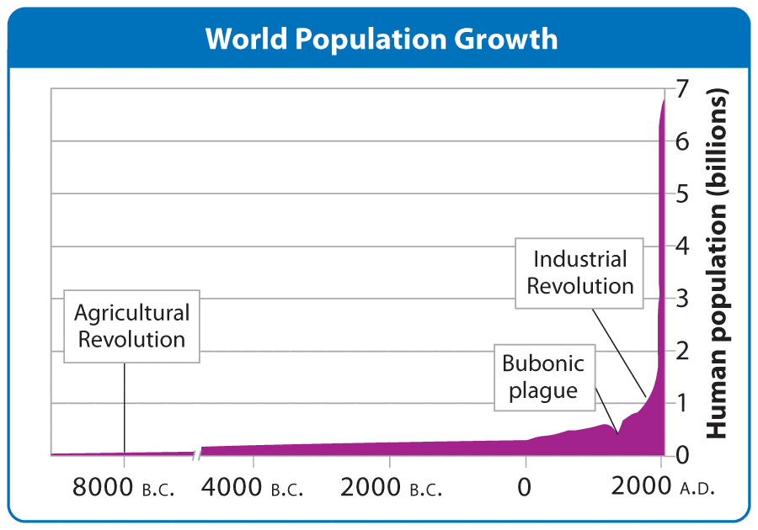
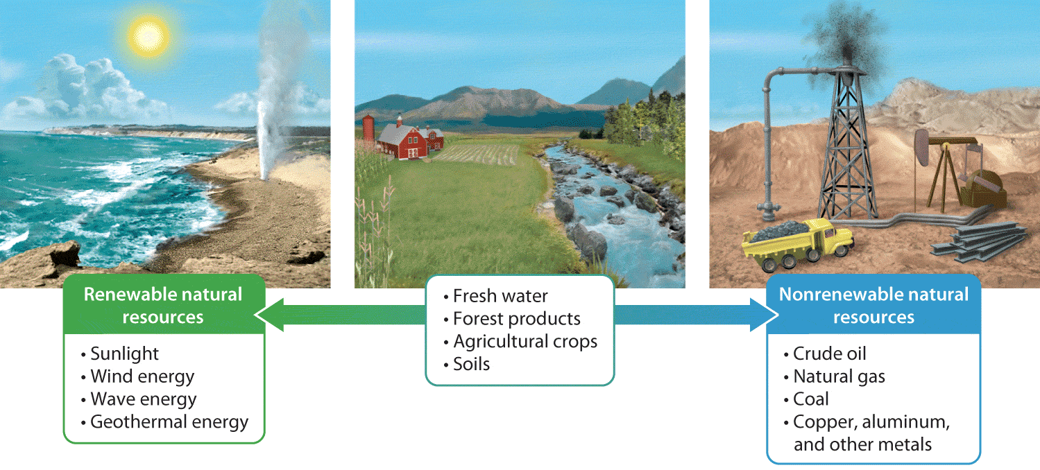

Human Population Growth
Tremendous and rapid human population growth can be attributed to:
•_______ ___________________ _________________: About 10,000 years ago; humans began living in villages, had longer life spans, and more surviving children.
•_____________ ________________: Began in early 1700s; driven by fossil fuels and technological advances

Ecological Footprints
The total amount of _______ & ________________ required to:
  - provide the raw materials an __________ or _______________ consumes
  - __________ of or _______________ the waste an individual or population consumes
Most informative when footprints are ____________ using the _______ ______________

Tragedy of The Commons
- Describes a ___________ ___ _________ ____________, made available to everyone, are ______ ____________ & ___________ _________________
- ____________ _____________, whether voluntary or mandated, can help avoid resource depletion.
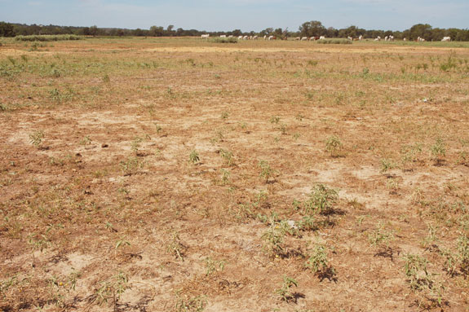
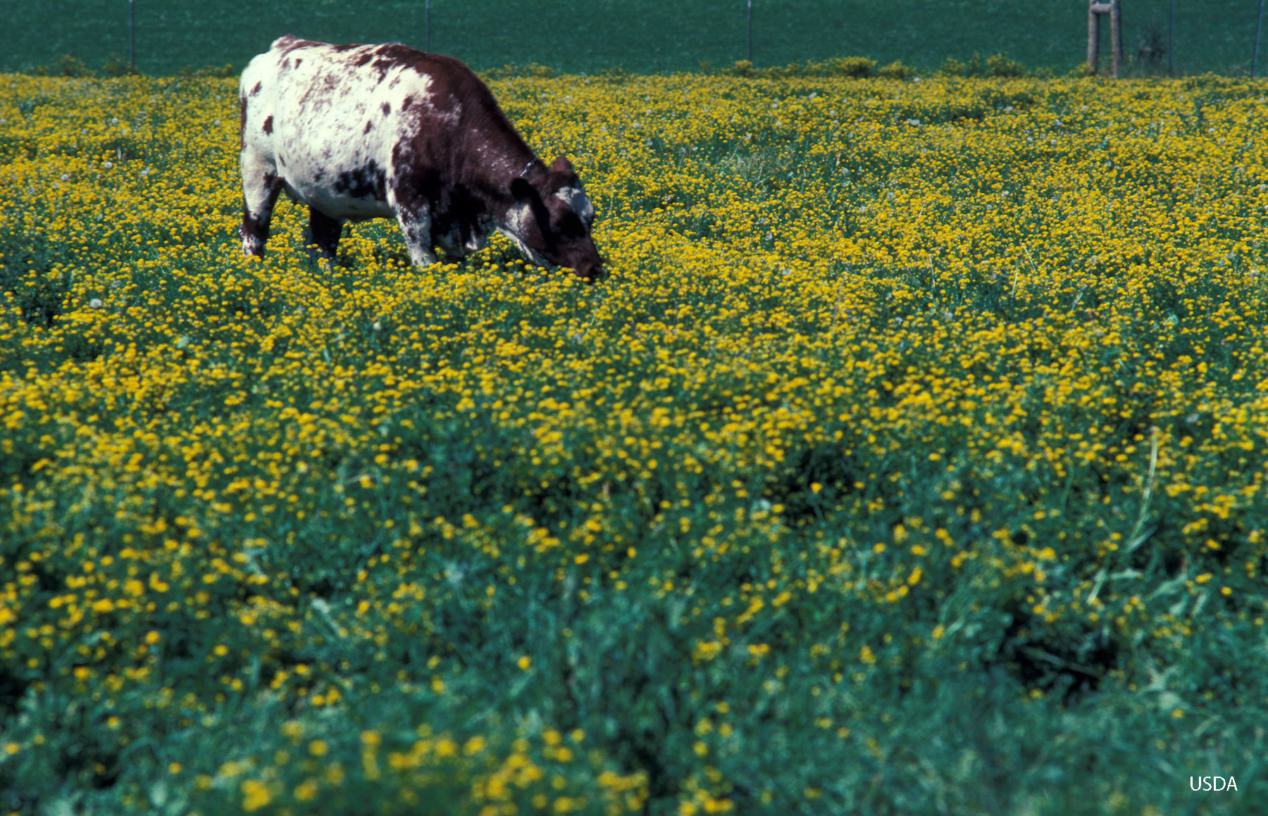
The “commons” refers to a __________ ___________________ that was shared by villagers in 19th-century England.

