Label Each Nail Shape

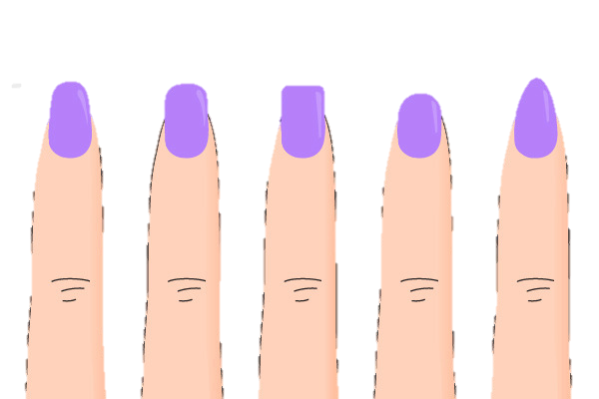

______________ ______________ ______________ ______________ ______________

Label each item with the appropriate name



  

