Name: __________________________________________________________ Date: _______________________ Class: _______________

Directions: Fill out the chart about the first ten amendments, known as the Bill of Rights.

Amendment | Official Writing | Write the amendment in your own words | Where do you see this today? | Visual/Memory picture with title
Amendment 1 | Freedom of Speech | I can say whatever I want to say | Facebook, Twitter, newspapers, CNN | Protest over Vietnam war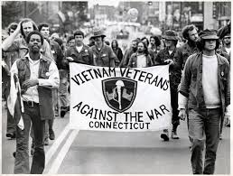
 | Freedom of Assembly/Petition
 | Freedom of Religion
 | Freedom of the Press
Amendment 2 | The right to bare arms (carry/own a gun) and create a militia in times of need.
Amendment 3 | The government cannot force your family to let soldiers to live in your home.
Amendment 4 | Bans unreasonable searches and says police must obtain a search warrant from the judge ahead of time
Amendment 5 | - a jury must decide of there is enough evidence against you,  - can’t be tried for the same crime twice  - you don’t have to testify against yourself  - You can’t be put in jail without a trial  - the government cannot take your property without paying you for it.
Amendment 6 | For people accused of a crime. – you have to be told what you are being arrested for – a speedy trial – a jury – challenge your accusers – right to a lawyer
Amendment 7 | For civil courts (someone is suing someone else) – every person is allowed to have a trial
Amendment 8 | Punishment, bail, and fines must be reasonable – not cruel or unusual
Amendment 9 | People have rights other then those listed in the Constitution. The government cannot interfere with them. (You have the right to be happy)
Amendment 10 | Congress cannot do anything other then what the Constitution says it can do. All else is left up to the states or to the people. (basically federalism)

