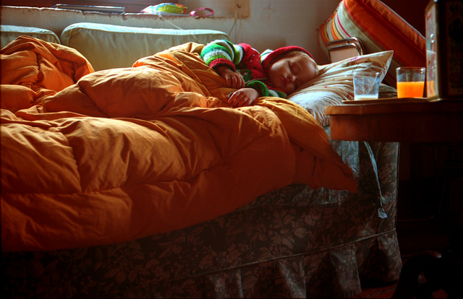
This week in class, we’re reading "What the flu does to your body, and why it makes you feel so awful" by Laura Haynes.
In the informational text, “What the flu does to your body, and why it makes you feel so awful,” Laura Haynes explain how the immune system’s response to the flu makes us feel sick.
As we read, we will be discussing the themes of Education & Knowledge and Man vs. Nature as they relate to the text. We are trying to answer these big questions :
"How do we understand the world around us?" and "Who's in control: man or nature?"
Ways to support your child:
- Ask your child about this informational text at home:
  - What was "What the flu does to your body, and why it makes you feel so awful" About
  - What did you learn about? About Man vs. Nature?
- Watch the following clips with your child at home:
  - 'Flu Attack! How A Virus Invades Your Body | Krulwich Wonders | NPR'
  - 'The surprising reason you feel awful when you're sick - Marco A. Sotomayor'

