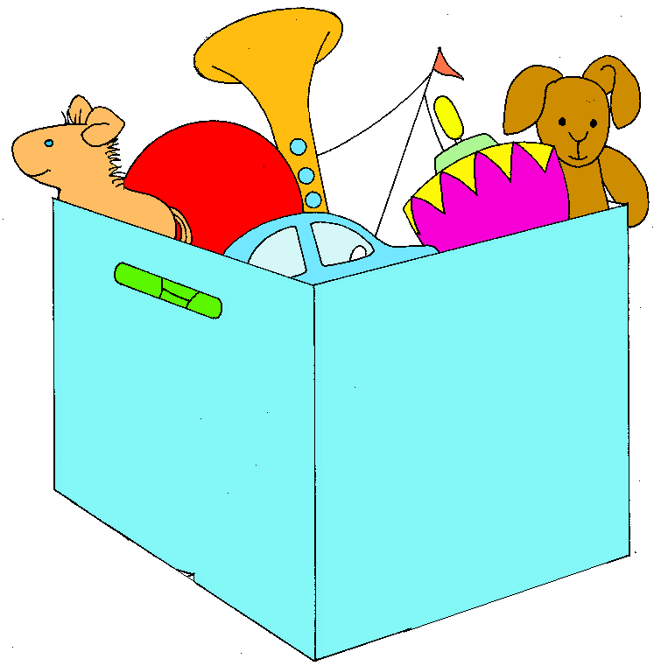
Play and Child Development
Notes & Lab

The Developmental Purposes of Play
Play helps children to grow and learn in many areas of life, such as:
- __________________________: Children learn new words to explain the toy and how the game is played. Older children use language to explain rules and agree on fair play.
- __________________________: Play helps children develop their bodies, especially balance and coordination.
- __________________________: Children can express emotions during pretend play and learn strategies to deal with their positive and negative feelings.
- __________________________: Children learn turn-taking, sharing, and become skilled at noticing others’ feelings.
- __________________________: Play teaches children about cause and effect, problem-solving, and can develop memory.

Toys and Play: Ages and Stages

0-3 months | 6-12 months | 1-2 years
Developmental Milestones:  • Sees black/white, later color  • Begins to recognize familiar people  • Push up to hold self up on tummy with arms  • Hands to mouth  • Learns to follow people/objects with eyes | Developmental Milestones:  • Roll over  • Hold head up / Sit Up  • Crawl / Standing with support  • Babble speech / Knows name  • Pass objects between hands  • Grasp with fingers | Developmental Milestones:  • Walking / Running  • Sorting  • Imitates others  • Empathy (feels others’ feelings)  • Language improves (knows shapes, colors)  • Improved hand coordination
Types of Toys: | Types of Toys: | Types of Toys:
3-4 years | 5-7 years | 8-10+ years
Developmental Milestones:  • Imagination  • Improved overall coordination with movement- ex) Can Pedal Tricycle  • Speaks fluidly and with detail  • Plays with others | Developmental Milestones:  • Beginning readers  • Improved attention span  • Understands turn-taking and game rules  • Knows not to put items in mouth  • Follows directions | Developmental Milestones:  • Independence  • Peer-focused  • Clear interests emerge  • Follow rules consistently  • Interest in how things work
Types of Toys: | Types of Toys: | Types of Toys:

For all ages, parents should consider if a toy is:
- __________________________
- __________________________
- __________________________ Magic Number: __________inches for kids under 5

