NAME: ___________________________________ HOUR: ______

Epic History - WORLD WAR ONE: 1914
- 1914: the Great Powers of Europe are divided into two rival alliances: The Triple Entente: France, Britain and _______________________, united by fear and suspicion of Germany.
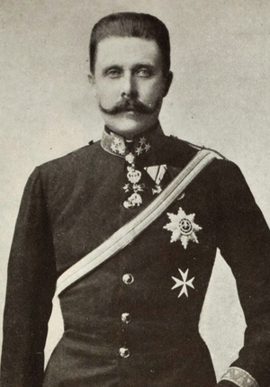
- Europe's new strongest power. And the Triple Alliance: Germany, which fears encirclement by its rivals;_________________________________, clinging onto a fragile empire; and Italy, seeking gains at French expense.
- Who was assassinated in Sarajevo, July 1914 to spark WWI? ______________________________________________________
- The Russian Tsar, Nicholas II, feels honour-bound to ________________ Serbia, a fellow Slav nation, and orders the Russian army to mobilise.
- What was the name of the German plan to avoid a two front war with France and Russia? _____________________________________________________
- Who declares war on Germany after Germany invades Belgium? __________________
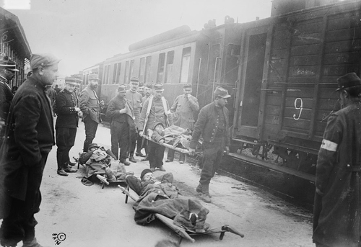
OPENING MOVES IN EUROPE

7. Where do the Allies finally make their stand? ___________________
- How many miles from Paris? _______

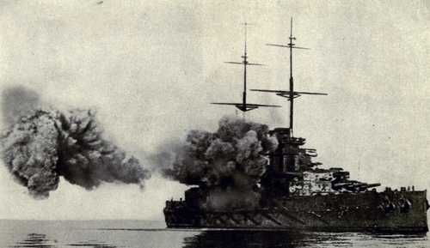
8. The Race to the ________' begins, as both sides try to outflank each other to the north.

THE WAR AT SEA

9. How many German cruisers were sunk by a British battleship at Heligoland Bight? _______

10. Britain has the most powerful navy in the world: They now impose a naval ____________________ on Germany, preventing contraband goods, including ___________, from reaching it by sea. The aim is to bring Germany's economy to its knees and force it to surrender.

11. What is now herald as deadly new challenge to Britain's command of the seas? German ___ - Boats

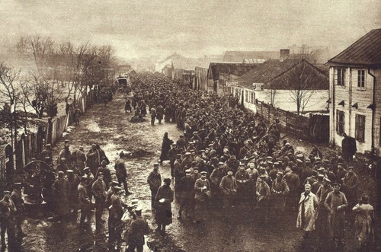
THE EASTERN FRONT

12. In the Battle of Tannenberg, August 1914, how many Russian soldiers were taken prisoner by Germany? ________________________________
13. Austro-Hungary's offensive against Russia also ends in disaster and retreat, with the loss of more than ___________________________________ men.
14. Who ends up joining the Central Powers, declaring war on its old enemy, Russia? _________________________________________

THE WORLD AT WAR
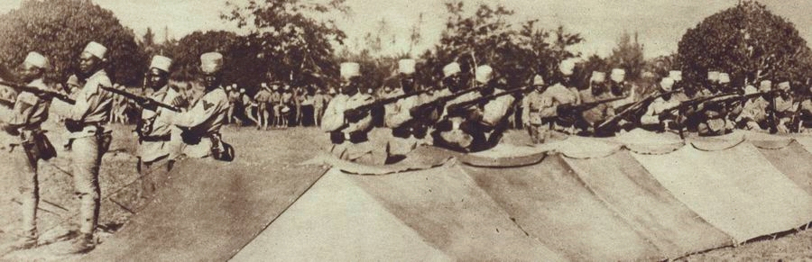
15. African soldiers, known as 'Askaris', fighting in German service in East Africa.
Beyond Europe, the war rages on the world's oceans and in far-flung European _________________________.
16. The German colonies of Samoa and New Guinea surrender to troops from New Zealand and ___________________________________.
17. While in the Middle East, British troops seize control of the Ottoman port of Basra, securing access to the vital Persian _______________ that fuels the British fleet.

WINTER 1914
18. That winter, Austrian troops finally capture Belgrade, but the Serbs then counterattack and drive them back once more. The fighting in Serbia has already cost around ___________ casualties on each side.

19. In the Caucasus, an Ottoman offensive through the mountains in midwinter ends in disaster at Sarikamish. Turkish casualties total 60,000, many ______________________ to death.

20. On the Western Front, the French launch their first major offensive against the German lines: but the First Battle of Champagne leads to small gains at a cost of ___________________ casualties.
21. That first Christmas is marked in some sectors by a short truce, and games of football in _______________________________, the killing zone between the trenches.
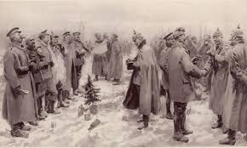
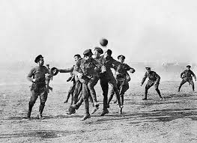

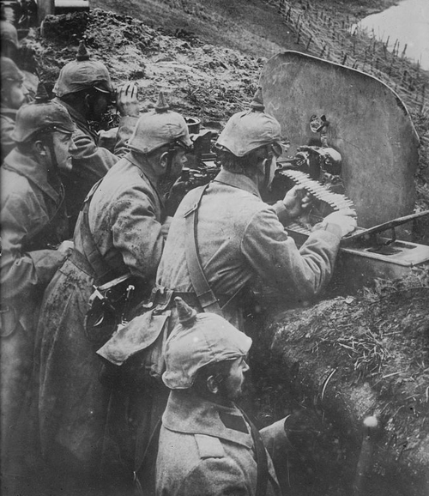
Name: ______________________________________

WORLD WAR ONE - 1915
- January 1915. World War One is just five months old, and already around _________ million soldiers have fallen.
- Austro-Hungarian troops have also suffered huge losses, and are humiliated by their failure to defeat ____________________.
- While on the Western Front, French, British and Belgian troops are dug in facing the Germans, in ________________stretching from the English Channel to Switzerland.
- 19th January: As part of the world’s first strategic bombing campaign, Germany sends two giant airships, known as __________________________, to bomb Britain.
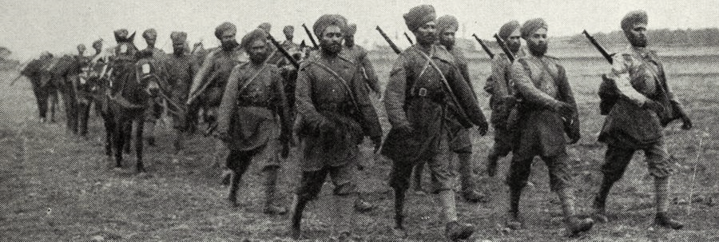
- 7th February: On the Eastern Front, German Field Marshal von Hindenburg launches a Winter Offensive, and inflicts another massive defeat on the Russian army at the Second Battle of Masurian Lakes. The Russians lose up to______________men, half of them surrendering amid freezing winter conditions.
- 10th March: On the Western Front, the British attack at Neuve Chapelle, but the advance is soon halted by German barbed wire and _________________________.
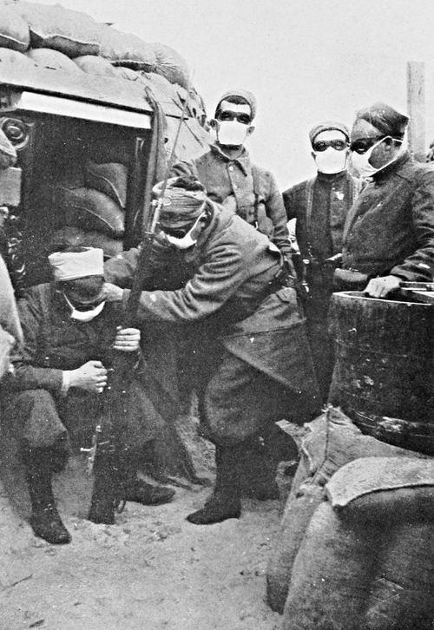
- 22nd April: At the Second Battle of Ypres, the Germans attack with poison _______ for the first time on the Western Front.
- 24th April: The Ottoman Empire begins the systematic deportation and murder of ethnic ________________ living within its borders. The Armenians are a long-persecuted ethnic and religious minority, suspected of supporting Turkey's enemies. left to die. In all, more than a million Armenians perish.
- 7th May: At sea, the British passenger-liner_______________________, sailing from New York to Liverpool, is torpedoed by a German U-boat off the coast of Ireland without warning. US President Woodrow Wilson and the American public are outraged.
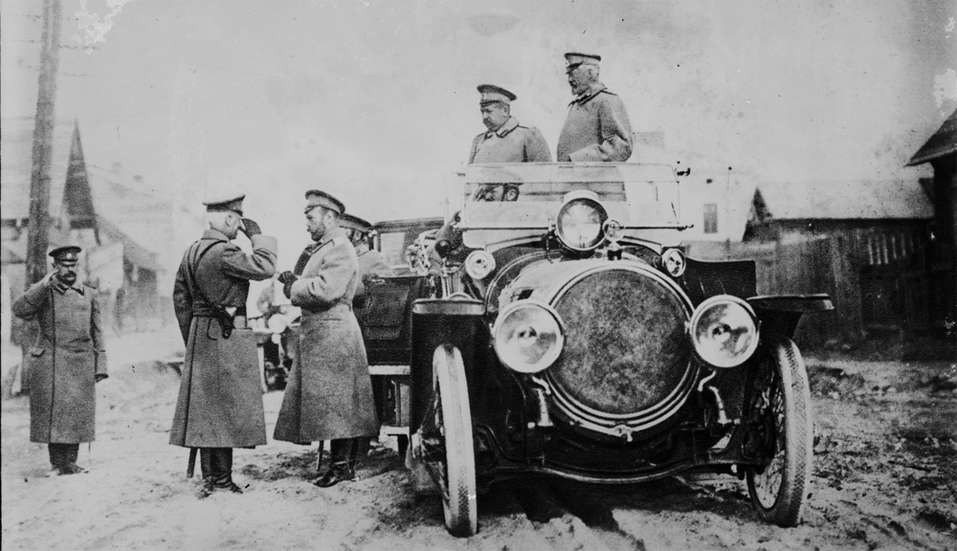
- 23rd May:Which alliance does Italy join? Central or Allied (circle the correct one)
- 1st September: In the Atlantic, a German U-boat sinks the liner SS Arabic: ____ are lost, including three Americans. In response to further US warnings, Germany ends all attacks on passenger ships.
- 3rd October: by the end of the war a third of __________ army has been killed – the highest proportion of any nation.
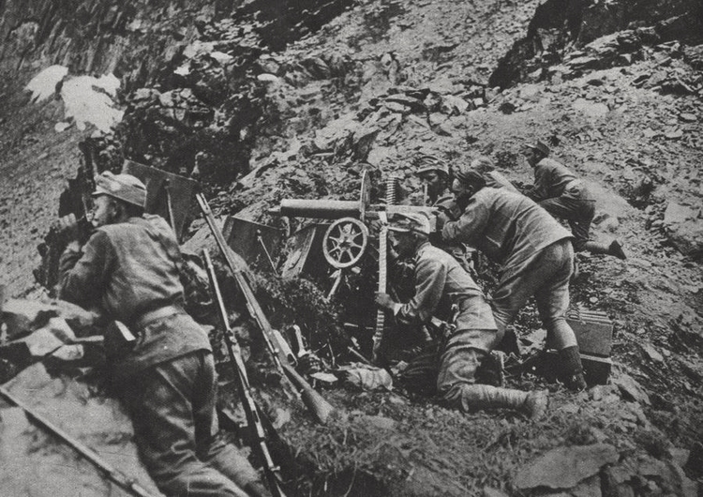
- 20th December: The Allies abandon the Gallipoli campaign. _____________ troops are secretly evacuated without alerting Turkish forces. Not a man is lost.
- Why is 1915 a bad year for the Allies? – enormous ________, for no tangible_______. .All sides still believe a decisive battlefield victory is within grasp.
Name: ______________________________________
Name: ______________________________________

WORLD WAR ONE - 1916
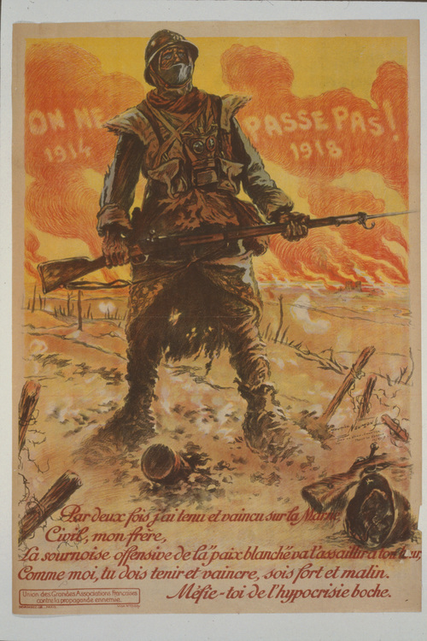
- World War One was supposed to have been a short and glorious war. But by 1916, a new kind of ____________________________ warfare had seen the death toll soar into the millions, with no end in sight.
- The war has raged for a year and a half, as the Allies continue to battle the Central Powers, recently joined by ___________________________
- While on the Balkan Front, the Central Powers have overrun Serbia, whose army is forced to make a bitter retreat through the _____________________ mountains.
- 21 Feb: On the Western Front, the Germans unleash a devastating assault on the French fortress-town of _______________________
- German General Erich von Falkenhayn knows France will defend this symbolic town to the last man. His plan, in his own words, is to 'bleed France white' in its defence. It is the strategy of ____________________.
- What battle becomes one of the most terrifying battles of the war? ______________
- 2 Mar: In Britain, one million men have already volunteered for military service. But the government realises it won't be enough: so in March 1916, Britain becomes the last major power to introduce ________________________________
- 9 Mar:On 9th March, Germany retaliates by declaring war on _________________
- 24 Apr: In Dublin, Irish republicans launch an armed revolt against British rule. It becomes known as the _______ Rising, and is put down after six days of street fighting.
- 31 May: In the North Sea, the German High Seas Fleet clashes with the British Grand Fleet at the Battle of ____________________. In the only major naval battle of the war
- 1 Jul: On the Western Front, Britain and France launch their major summer offensive: the Battle of the ____________________.
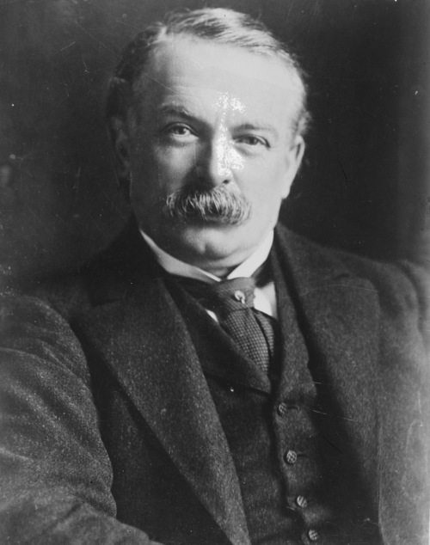
- 29 Aug: Who won the battle of Verdun? ____________________________
- 15 Sep: Meanwhile, the Battle of the Somme continues. What new weapon do the British introduce to the war? ____________.
- 18 Nov: The Battle of the Somme comes to an end amid autumn rain and mud. The Allies have advanced ________ miles at the cost of 600,000 casualties. German losses are about 450,000. The Allies reassure themselves that this is a winning strategy, because at this rate, Germany will run out of ________ first.
- 7 Dec: In Britain, Prime Minister Herbert Asquith is forced from office, and is succeeded by David Lloyd ______________________
- What US president attempts to mediate a peace settlement come to nothing?
________________________________________
- On your own: Why is Germany weary of the United States joining the war?

Name: ______________________________________

WORLD WAR ONE: 1917
- 1 February - Germany knows it will lose a long war of _____________________ against the Allies, who have greater resources.
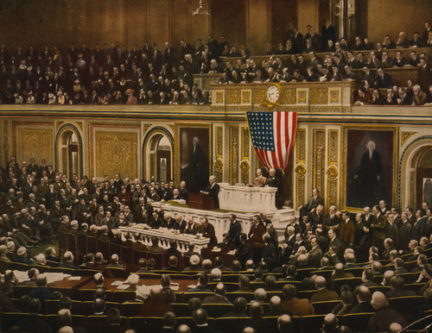
- What weapon does Germany use to cut off Britain's food imports by sea? ______________________
- 19 February - Name of the telegram that Germany sent to Mexico asking them to attack America? ________________________________________________
- 6 April - On April 6th, the United States declares war on ________________________________________
- What do reconnaissance aircraft do?

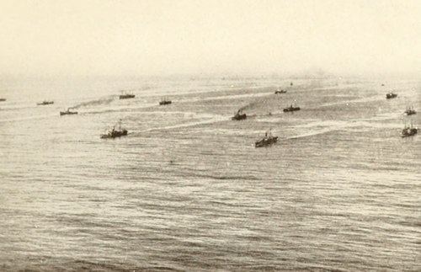
- 7 June - That summer, at Messines Ridge, the British tunnel under the German lines, and detonate ____ enormous mines under the enemy position.
- 2 July - At sea, the Allies begin to group their merchant ships into _________________, which sail under naval escort. The new system leads to a steady fall in losses.
- 4 August - Liberia declares war on Germany, after its capital is shelled by a German ______________________
- 31 October - the British, after two defeats, finally win at the Third Battle of Gaza, clearing the way for an advance into __________________________

- 13 November - What is Prime Ministers Georges Clemenceau nickname? ___________

- 6 December - Finland declares independence from ____________________
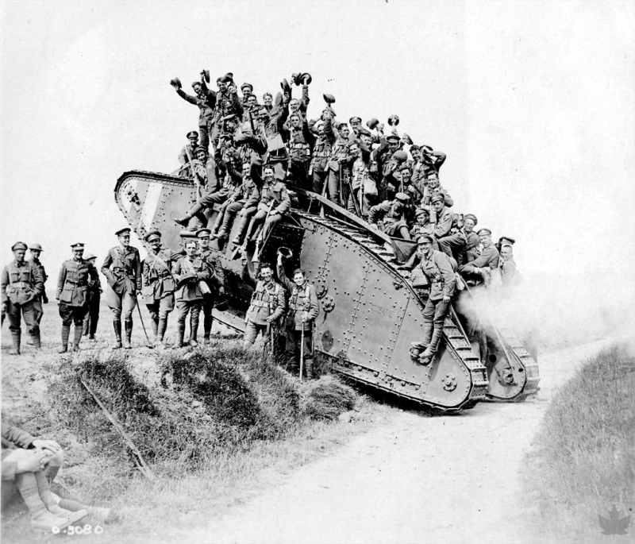
- In 1917 which major allied power is knocked out of the war? ______________________

- In 1917, which major country joins the Allies to fight Germany? ____________________

- In your own words, describe what War of Attrition means?

- Why is America's entrance into WWI significant?

Name: ______________________________________
WORLD WAR ONE: 1918
- What government has signed an armistice with the Central Powers in 1918?
- Germany faces inevitable defeat, unless it can win a quick victory on the ___________ Front.
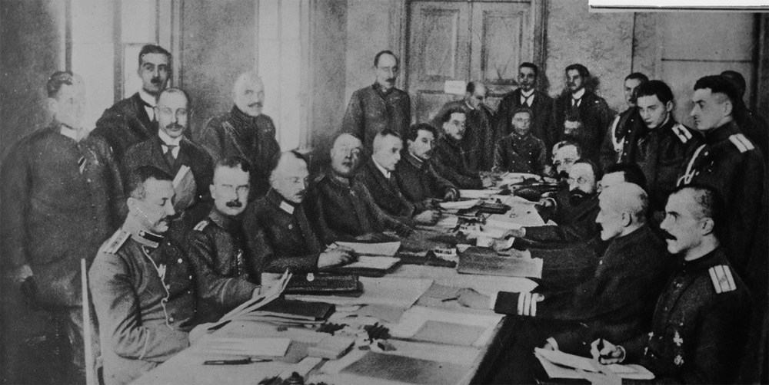
- 8 January - US President Wilson announces his 'Fourteen Points'. They outline his vision for a post-war world, including an end to secret _________________, a reduction in the size of armed forces, ______________________________ for the people of the Austro-Hungarian Empire, and an international organisation to settle _______________ disputes.
- 3 March - What does Russia give up in exchange for peace?

- Why have the Allies won air superiority over the Germans?

- How many victories did the ‘Red Baron’ have and what happened to him near Amiens?

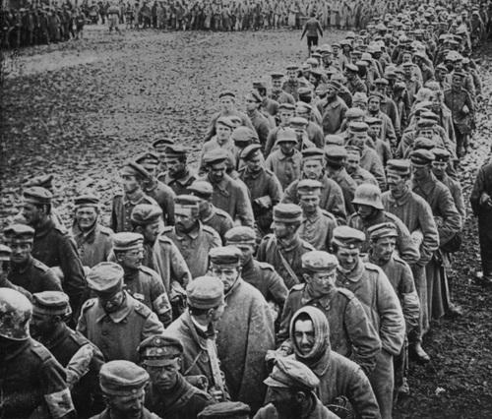
- 15 July - On the Western Front, the Germans' final attack is defeated in the Second Battle of the Marne. How many German Casualties? _______________________
- 8 August - The Allies now go on the attack. German troops are exhausted, hungry and demoralised, and begin to _______________________ in their thousands. Trench warfare is over; the Germans are in full ____________________
- 4 October - Ludendorff informs the Kaiser that the military situation is hopeless, and that Germany must seek an ________________.
- 11 November -What did Germany do on November 11th?

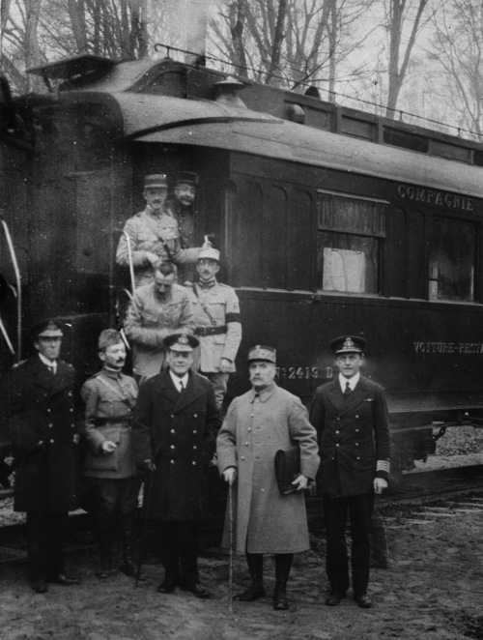
- 18 January 1919 - The Paris Peace Conference opens at the Palace of Versailles, just outside the French capital. Delegates accept a proposal to create a '_____________________________’ to settle future international disputes.
- 4 June - The Versailles Treaty is signed. |t imposes harsh terms on Germany: List 3 things Germany had to do:

- The boundaries of Europe are redrawn: ________________ re-emerges after a hundred years of foreign rule.
- What Empire is dismantled? ________________________________
- How many soldiers were killed in WWI? ___________________________
- How many civilians were killed? ________________________

THE RUSSIAN REVOLUTION
“I shall never agree to a representative form of government, because I consider it harmful to the people whom _____ has entrusted to my care.” Nicholas II 1904

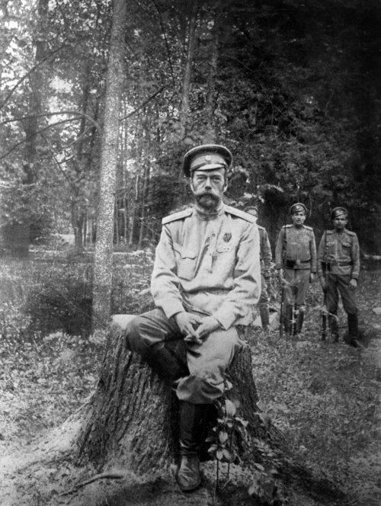
- In 1894, Nicholas II became ruler of a Russian empire that stretched from the Baltic to the Pacific, inhabited by _______ million people, from 194 ethnic groups.
- What is the state duma? _____________________________________
- What happened to Grigory Rasputin in December 1916?

- 23rd February 1917 -International Women's Day to protest over _________________ shortages.
- What did Nicholas agree to do on the 2nd of March?

- Who was the leader of the Bolsheviks?

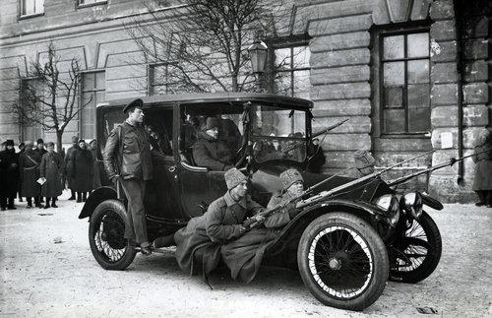
- What was Lenin's simple slogan to the people?

- With the help of Stalin, where did Lenin flee to avoid arrest?

- In October, Lenin decided the time had come. He secretly returned from Finland to Petrograd, and began preparing to seize ____________________
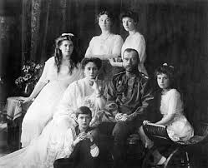
- The following months saw the Bolsheviks consolidate their hold on power, while fighting a brutal civil war against counter-revolutionary, or '___________________ Russian', forces, who had foreign support.

- What happened to Czar Nicholas II, his family and 4 servants? ________________

- Russia's civil war was one of the 20th century's most devastating events. An estimated __ million soldiers lost their lives, while a typhus epidemic and famine claimed the lives of a further __ million civilians.

- What was created in 1922 under Lenin? ______________________________________

- On your own: Explain IN DETAIL 3 causes of the Russian Revolution. Be sure to use complete sentences and explain how each cause led to the Revolution. Use a seperate sheet of paper if you need more room.

