Background info (Info you need to read 1st)
Before the Scientific Revolution, scholars in Europe relied on two main resources to study the world around them: 1) they listened to the church and ancient Greek philosophers and 2) the relied on their observations and senses. Though these sources could both be accurate from time to time, they were not reliable. Your own observations can sometimes be truthful – but if you observed your current surroundings, I bet you wouldn’t come to the conclusion that the earth is moving or that our planet is a sphere. That’s where evidence and facts and the Scientific Revolution comes in! The Scientific Revolution is a time period between the 1540s-1700s in Europe where many scientific discoveries and changes led to the birth of modern science!

**DIRECTIONS: For each of the Scientific Revolution scientists below, read the info about them. Then complete the activity. You can choose to do all of these activities either in video form/illustrations/or in written format! Once you’re done with all of these activities, feel free to send them to your teacher through their preferred method (Curve, email, etc.) so they can see your work!

Scientist #1: Francis Bacon ( Jan. 22,1561- April 9,1626)
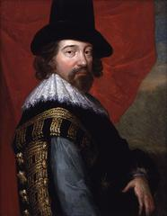
The Scientific Revolution changed the way we learn about the world. People started studying science in an organized way and requiring proof to back up ideas. One man, Francis Bacon, created the Scientific Method, which is a step-by-step process of performing scientific research. Before him, most ideas and beliefs were based on observation, interpretation, and teachings of the church rather than facts. The goal of his Scientific Method was to create a system of scientific study that relied on observation, evidence, and experiments. He felt that systematic observations and carefully organized experiments would lead to new factual discoveries. The Scientific Method changed the study of science forever. It is still the basis for modern day scientific research and study.

**The scientific method was originally called the Baconian Method but evolved into what we know today. In the Scientific Method, the scientist does the following things:
- First they observe the world around them and identify a question or problem
- Then they come up with an idea about why that situation occurs (a Hypothesis)
- They then perform an experiment to test their idea/hypothesis
- Analyze the findings (to see if their idea/hypothesis was right or wrong)
- And finally state their conclusions (Basically, they state the results of their experiment)

**ACTIVITY:

Using the information about Francis Bacon, you need to go through the steps of the Scientific Method on your own! You will start by observing the world around you and identifying a question or problem you see. Then you will continue through the rest of the steps. Make sure you choose something safe! You have the option or explaining your process in writing, drawing it out, or recording it!

Scientists #2: Nicolaus Copernicus (Feb. 19, 1473 – May 24, 1543) and Johannes Kepler (Dec. 27, 1571 – Nov. 15, 1630)

Copernicus was a Polish astronomer who wrote the book, On the Revolution of the Celestial Spheres. This book is considered the start of the Scientific Revolution. Copernicus’ book disagreed with the ancient Greek thinker Ptolemy, whose theory that the sun and planets moved around the earth had been accepted and believed for almost 2,000 years. This was called the geocentric theory.
Copernicus observed the movements of the planets and believed that rather than the planets revolving around the earth, all of the planets (including earth) moved around the sun in circles, which is called the heliocentric theory. He never proved his theory, but it had a great impact nonetheless.
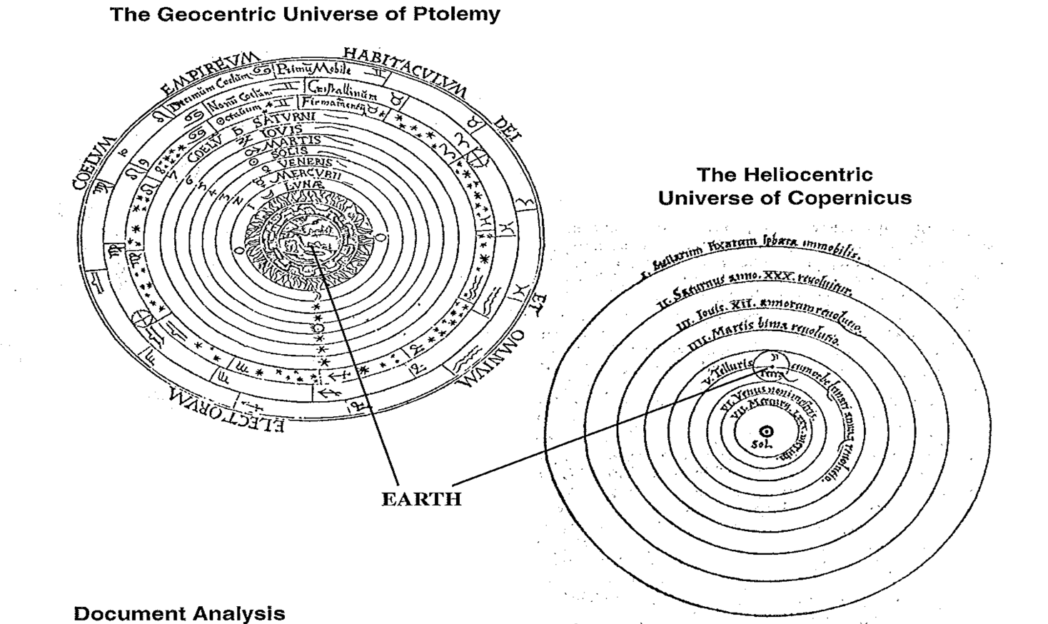
This idea seems simple now, but at the time Copernicus was challenging the layout of the universe. Because the Bible said that God made the earth and then the Heavens, the Catholic Church believed that the earth was the center of the universe. Copernicus was nervous to publish because he knew they went against the beliefs of the Catholic Church and he might be punished. He died before he could be brought to trial for his theory.

(Continued on the next page)
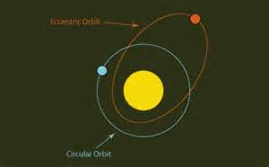
Johannes Kepler was a mathematician and astronomer. He used the scientific method to help prove Copernicus’ heliocentric universe idea to be true. He did, however, disagree with Copernicus’ idea that the planets moved around the sun in circles. In his three laws of planetary motion he included the discovery that planets moved in elliptical (oval) orbits rather than perfect circles. His laws are still considered true today, 500 years later.

**ACTIVITY:

Using the information about Copernicus and Kepler, you need to create a model showing the two different theories about the motion of the planets! One model should represent the ancient Greek idea of how the planets rotate – the geocentric theory. The other model should show Copernicus and Kepler’s theory – the heliocentric theory. Use objects at your house and label them if needed to make your work clear. You have the option of creating a video to show your work, taking a picture of it, or creating an illustration of it. Do not simply copy and paste a picture of it from the internet.

Scientist #3: Galileo Galilei (February 15, 1564, January 8, 1642)

Italian scientist Galileo Galilei is often called the Father of Modern Science. He was the first person to study the sky with a telescope and saw that the moon had craters and mountains and discovered that moons orbit Jupiter. These observations helped Galileo further prove Copernicus and Kepler’s belief of a heliocentric universe.
Galileo was also interested in how falling objects behave. He realized that 2 objects, regardless of their weight, fall at the same speed. His biggest contribution to science, however, was the way he learned. Instead of just observing things in nature, Galileo set up experiments to prove whether they were true or not. In fact, Galileo was the first scientist to regularly use experiments to test his theories (ideas).
His habit of bragging earned him enemies among the Catholic Church’s leaders. Galileo was put on trial by the Inquisition for many of his scientific breakthroughs because the Catholic Church believed they went against church teachings. To please the church and avoid death, Galileo took back his findings and was forced to live his remaining years under house arrest.
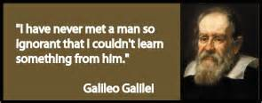

**ACTIVITY:

Using the information about Galileo, you need to test his theory about falling objects. FIRST, I want you to prove his theory about falling objects. Find 2 nonbreakable items and perform an experiment to prove his theory. SECOND, choose 2 objects and see if you can disprove his theory. Use objects at your house but be safe (don’t break anything!). Take a video of your experiments.

Scientist #4: Sir Isaac Newton (January 4,1643 – March 31,1727)

The high point of the Scientific Revolution came with the publication of Principia Mathematica. The author of this book, published in 1687, was the English scientist Sir Isaac Newton. Newton was one of the greatest scientists who ever lived. Some of his theories have been proven so many times they are now called laws. Newton came to the realization that a force exists that attracts objects to one another. This is the same force that makes the planets orbit the sun. He called this force gravity (as we do today) and this idea became the Law of Gravity (a law is a theory that is proven).

Newton built off of Galileo’s findings and developed three more laws of motion. They describe how objects move:

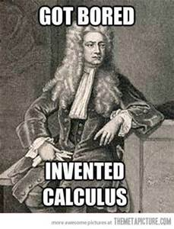
1) An object at rest will remain at rest unless acted on by a force. An object in motion will stay in motion with the same speed and in the same direction unless acted upon by a force.

2) Acceleration happens when a force acts on an object. The heavier the object being moved,) the greater the amount of force needed to move the object.

3) For every action there is an equal and opposite re-action.

**ACTIVITY:

Using the information about Newton, you need to prove his laws of motion. For each law of three laws of motion listed above, find a way to demonstrate that particular law. Make sure to do this in a safe way! You have the option or explaining your demonstration in writing, drawing it out, or recording it!

Once you have finished all of these activites, feel free to send them in to your teacher through their preferred method (email, Curve, etc.) so they can see your work!

